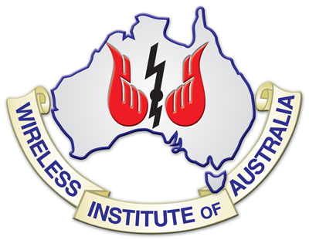

Backgrounder: Amateur Radio

What is it?
For those involved it is fun, a way to learn and make new friends, a technical communications hobby or recreational activity that provides a true sense of personal achievement.
While we commonly hear about Facebook, YouTube and Twitter, long before they came along amateur radio was the world’s first social media network and it continues to provide that role today.
While many talk on amateur radio, across town or around the world, radio amateurs also communicate in other interesting ways - more details later in this backgrounder.
There is also a serious side to it with radio amateurs providing emergency communications. When disaster strikes the telephone, mobile phone and internet connection often fail or are overloaded.
This aspect of amateur radio, that gives support to rescue, relief and recovery efforts and saves lives, was seen following earthquakes and tsunamis in recent years including those in China, Indonesia, Italy, Japan, Haiti and Chile.
The New York World Trade Centre terrorist attack on 11 September 2001, Hurricane Katrina 2005 and other major disasters have involved radio amateurs providing their skills and support.
In Australia emergency communications were provided in response to the Black Saturday bushfire disaster 2009.
That followed a tradition which began in the 1920’s during tropical cyclones in Queensland, the Black Friday bushfires in Victoria 1939, and includes the New South Wales floods in 1955, Tropical Cyclone Tracy 1974, Ash Wednesday disaster 1983, Newcastle Earthquake 1989 and on numerous other occasions.
Around the world regular training occurs so radio amateurs can be prepared to use their skills when required.
Who are these radio amateurs?
There are 16000+ radio amateurs in Australia and over two million in nearly every country in the world. They come from all walks of life – students, retirees, all kinds of professional people, truck drivers, tradespeople, hospitality staff, entertainers and others engaged in creative occupations.
They are part of the world wide amateur radio community that has people of all ages with a common interest in radio communication, a start-up knowledge of today radio technologies, regulations and operating protocols.
Why a licence?
For more than a century those engaged in amateur radio have needed to demonstrate their knowledge in basic technical matters and the rules of the airwaves or regulations. They obtain an internationally recognised certificate, then a licence and their own personal radio callsign to operate.
Because radio does not stop at international borders it is subject to an international treaty to which Australia is a signatory. An amateur radio licence is like an international passport, except rather than personally travelling to other countries you do so via the airwaves.
The radio amateur makes friends in other countries, has an opportunity to learn more about their culture, and contribute to international goodwill.
What's the attraction of amateur radio?
Some are attracted by the ability to generate a radio signal and communicate across town, around the world, and even with astronauts on the International Space Station. Others bounce signals off the moon or communicate via satellites.
Some like to build their own equipment, accessories and antennas or experiment with leading edge technical developments, connecting a computer with a radio to communicate via a keyboard, or send and receive images and amateur television signals.
For young interested in any kind of technical or science career there is no better personal activity than amateur radio to give them hands-on experience and stimulate their minds.
It has led many to technical careers, including leaders in their fields who have obtained the Nobel Prize and credit their early interest in amateur radio as a contributing factor to their success.
The amateur radio community in the 21st century includes those experimenting with the latest electronics and advanced technologies. These include wireless digital communications, software defined radios (SDR), long-distance digital and image transmissions.
While others enjoy keeping the original communication system, Morse code, on the airwaves and are just as skilled as the earlier wireless telegraphers who began it all in the late 1890s.

